THE ALBANY SCHOOL- Winter Term All pupils welcome
PHYSICAL EDUCATION DEPARTMENT – CLUBS & TERM PRACTICES PROGRAMME
 | 1st Break 11am- 11:30am 2nd Break 1:30pm -2pm |  |  |  | Afterschool  Mon-Thurs 3.00pm-4.30pm Fri 2.40-4.00pm
Mon | 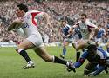  Year 7 & 8 Rugby  Mr Veares | 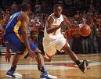  Basketball (all years)  Mr Norris | Years 9, 10 & 11  Badminton  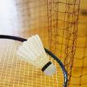  Miss Green | Year 7 Football  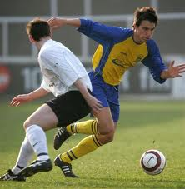  Mr Coleman | Year 7 Football  Mr Coleman | All years Rugby  Mr Norris & Mr Veares
Tues | Gym Club  Girls  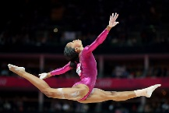  Miss Green | Year 7 & 8 football  Mr Coleman | Basketball 7 & 8  Mr Norris | Yr 7 football & 7 &8 Rugby  Mr Veares  Mr Coleman | Year 8 Football  Mr Coleman | 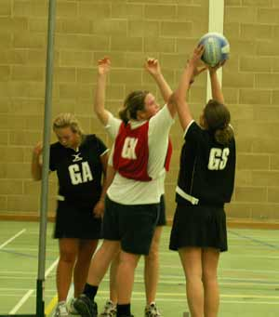  Yr 7, 8 & 9 Netball All years Martial Arts  Mrs Abbott (7)  Miss Green (8 &9) Mr Ahmed (Gym)
Weds | Years 9, 10 & 11  Badminton  Mr Norris | Year 7 ,8 & 9 Rugby  Mr Veares | All years Girls Football  Mr Coleman |  | All years Girls Football  Mr Coleman | All years Rugby  Mr Norris & Veares | Year 9 football  Mr Evans
Thurs | Basketball  Mr Norris |  | Yrs. 7,8 & 9 Rugby  Mr Veares |  | Years 10 & 11 football  Mr Norris | Years 10 & 11 Netball  Mrs Hutcheson
Fri |  |  | Fitness & Rowing Club  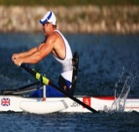  Mr Norris |  | GCSE  Catch up | Badminton/Tennis Club  (Sports Hall) | Gym club  Boys  